SolarInfo Bank
User Manual
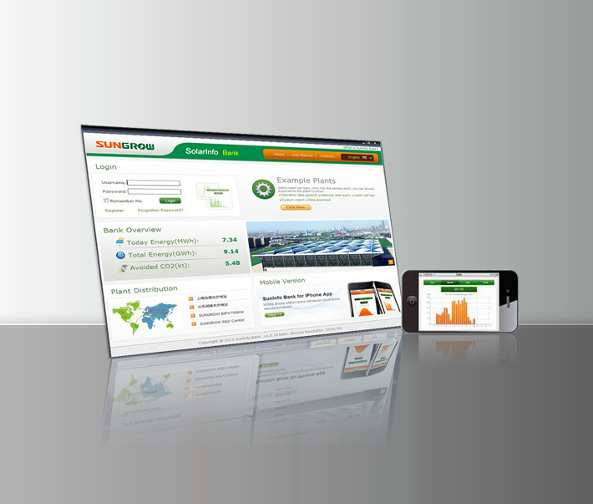

About This Manual

Target
This manual is designed for SolarInfo Bank operators.

Symbols Used in This Manual

NOTE indicates additional information, emphasized contents or tips to help you solve problems or save time.

Statement Description
Type | Statement Examples in This Manual
Select a menu option | Select ”Add station”
Select multiple menu options | Select “Configuration -> User information”
Select a button | Select [OK]

1 System Introduction

1.1 Introduction to the System
SolarInfo Bank system is web-based remote monitoring system. After a power station is connected with the system, you can register as a SolarInfo Bank user, create a power station and bind with the equipment data source to perform real-time monitor on operation status of the power station, obtaining key data about power generation capacity, power, carbon dioxide emission reduction and profits. Therefore, you can easily view the equipment operation status, including fault and alarming information, and perform effective evaluation on the operation status of the power station with various analysis charts and report definitions.
SolarInfo Bank provides various functions for you to monitor and visualize the PV power system, including:
- Manage power plants, for example, add, edit or delete;
- Display current power quantity, total power quantity, sunlight strength, temperature, reduction of carbon dioxide emission and profits;
- Locate the power station on Google Map;
- Display system data through charts and tables;
- Customize various charts;
- Customize various reports;
- View equipment operation status and alarming information;
- Receive operation reports and fault reports through E-mail;
- View video monitoring images of equipment through the system.

1.2 System Architecture
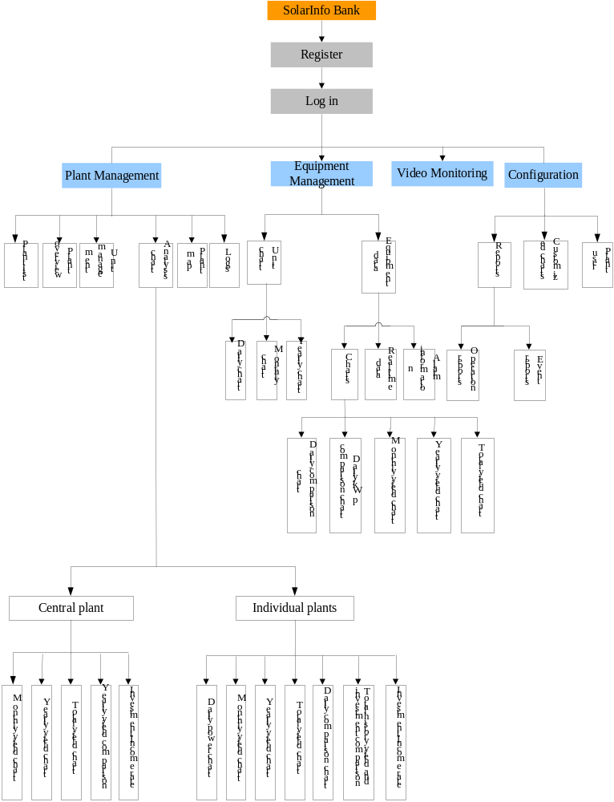

2 Registration
1. Access the SolarInfo Bank system and enter the homepage, as shown below:
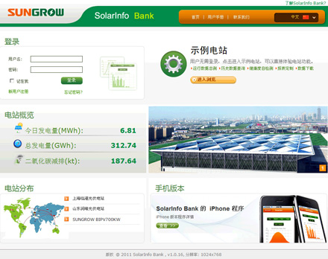
Today energy: The sum of yield of all stations in the system of today;
Total energy: The sum of yield of all stations in the system of all times;
Avoided CO2: total yield * carbon dioxide conversion rate.
2. Click [Register] on the homepage.
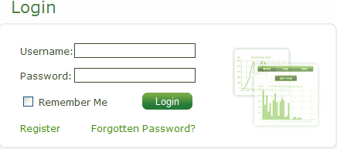
3. The User Registration page is displayed as shown below:
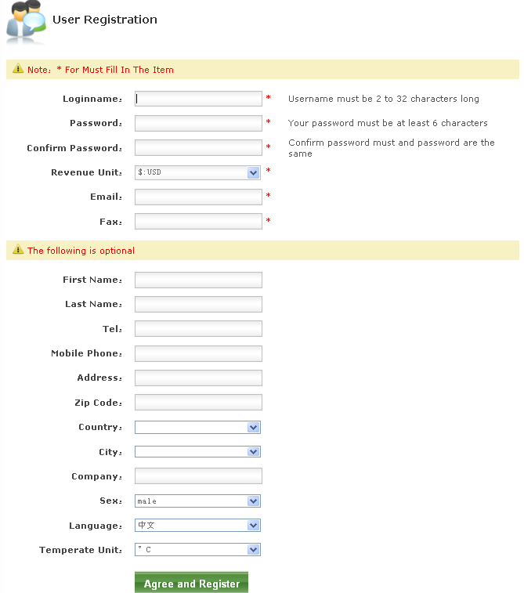
4. Correctly fill in relevant fields according to requirements and select [Agree and Register] to complete registration.
User Agreement: Please click “《User Agreement agree to make》” to read agreement contents before registration. If you click [Agree and Register], it means you accept the terms and conditions of the agreement. If you do not accept the agreement, please stop registration.
Currency unit: Several frequently used currencies are listed. Please select corresponding currency units. The revenue in the overview page will be displayed in the selected unit.
Temperature unit: ºC and ºF. Select a temperature unit. The temperature will be displayed in the selected unit in the overview page of relevant power station.
Language: Currently, the system supports only Chinese and English. After you log on to the system, the system language will be automatically switched to the language you set.
☑ After registration, the Success page is displayed.
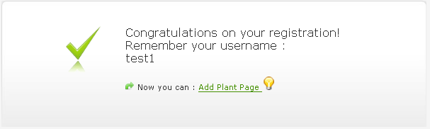
You can click [Add Plant Page] on the Success page to open the Add plant page for adding plants. For details about plant adding, please refer to section 6.1.

3 Login

3.1 Automatic Login After Registration
After registration according to procedures described in “3 Registration”, you can log in the system automatically.

3.2 Re-login
1. Enter your username and password on the homepage.
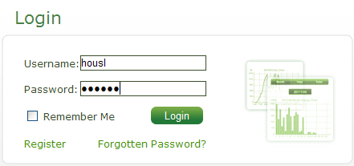
2. Click [Login].
☑ Logging in the system is complete successfully.

3.3 Automatic Login
1. Enter your username and password on the homepage and check “Remember Me”.
2. Click [Login] to enter the system.
3. Close your browser and then access the system again. You can log in to the system automatically.

3.4 Example
On the system homepage, click [Click to view]. You can log in to the system automatically. As an example user, you are only entitled to view modules and cannot perform operations on them.
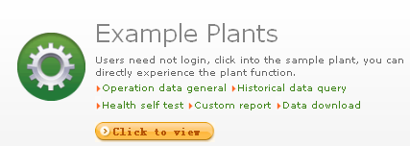

4 Page Description
The main interface of the SolarInfo Bank system has two parts:
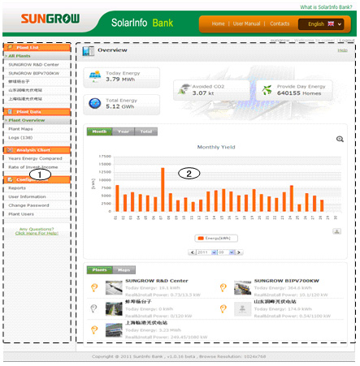
1. Navigation bar
Main Menu | Description
Plant list | List all plants added to the user
Plant data | Show relevant information and charts about equipment
Analysis chart | Display various charts
Configuration | Configuration of charts, reports and user information
2. Information display area
When you click submenus in the navigation bar, relevant information will be displayed in the area.

5 Personal Information

5.1 View/Modify Personal Information
You can view or modify your personal information according to your actual needs.
1. After logging in to the system, you can select “Configuration -> User Information” in the navigation bar.
2. Open the “Edit user” page to view/modify personal information.
3. After the information modification is complete, click [Save].
☑ The user information modification is completed successfully.

5.2 Change Password
You can change your password according to your actual needs.
1. After logging in to the system, you can select “Configuration -> Change Password” in the navigation bar.
2. The Change Password page is displayed, as shown below:
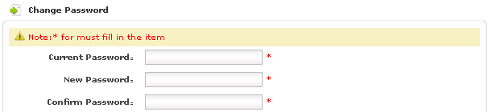
3. Enter the current password and a new password and then click [Save]. To cancel password changing, click [Cancel].
☑ The password changing is completed successfully.

5.3 Recover Password
If your password is forgotten, you can recover it through E-mail.
1. Click [Forgotten Password] on the system homepage.
2. The Forgotten Password page is displayed, as shown below: Enter your username and E-mail address you provided during registration.
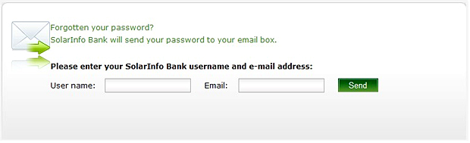
3. Click [Send]. The system will send your account and password to you through an E-mail. Then you can recover your password through your E-mail address.

6 Plant Management
With Plant management, you can add, edit and delete plants and bind units to plants.

6.1 Add Plant
If no plant has been added to your account, after you log in to the system, the Add Plant page is displayed automatically. To add plants after registration, please refer to section “6.1.1 Add Plant After Registration”. If you have added plants before, to add plants again, please refer to section “6.1.2 Add Plant Through Plant List”.

6.1.1 Add Plant After Registration
1. After registration, you are prompted to add plants. Then you can click [Add Plant page] to add plants.
2.The Add Plant page is displayed as shown below:
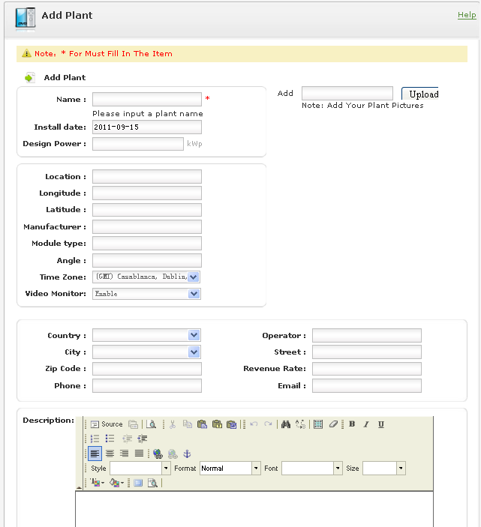
3. Enter relevant information correctly as described on the page. After filling all required fields, click [Save].
☑ The plant adding is completed successfully.
Time zone: A correct time zone of the plant should be provided to ensure the accuracy of the time of the plant.
Country and city: You can select from the dropdown menu or enter manually. Select “Other” from the country and city box. An input box is displayed. Then you can enter country and city name manually.
Video monitor: If “Enable” is selected, the “Video monitor” menu will be displayed in the navigation bar. You can view, add or delete monitoring. If “Disable” is selected, the “Video monitor” menu will not be displayed in the navigation bar.
Revenue rate: This option is used to set the price for unit electric quantity of the plant to calculate relevant revenues of the plant.
Uploaded image: Only jpg, png, gif, bmp and jpeg formats are supported. This option is used to adjust image height and width according to page layout.

6.1.2 Add Plant Through Plant List
1. Log in to the system.
2. Select “All Plants” from the navigation bar to enter the “Plant List” page.
3. Click [Add].
4. The “Add Plant” page is displayed. Fill in relevant information in all required fields and then click [Save].
☑ The plant adding is completed successfully.
6.2 View Plant Information
- Enter the "Plant Profile” page through the "Plant List” page
1. Select “All Plants” from the navigation bar to enter the “Plant List” page.
2. Click “Plant Name” on the “Plant List” page.
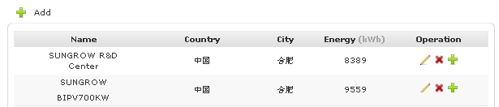
3. The “Plant Profile” page is displayed. You can view plant information on the page.
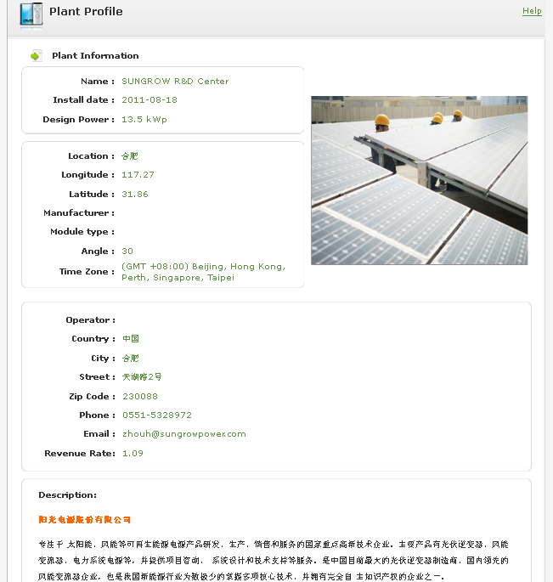
- Navigation Bar Menu
1. Select “Plant List -> Plant Name” from the navigation bar.
2. Select “Plant Data -> Plant Overview” from the navigation bar. The “Plant Profile” page is displayed. Then you can view the plant information.

6.3 Edit Plant
1. Select “Plant List -> All Plants” from the navigation bar to enter the “Plant List” page.
2. After the page is displayed, click [Edit].
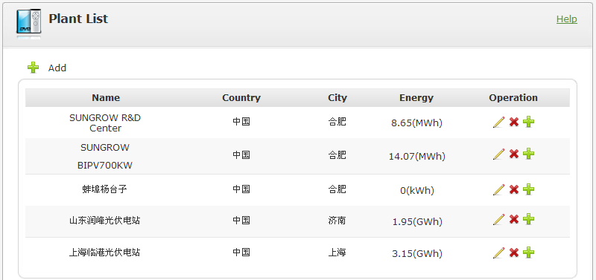
3. The “Edit Plant" page is displayed. Then you can edit relevant information of the plant.
4. Click [Save].
☑ The plant editing is completed successfully.

6.4 Delete Plant
1. Select “Plant List -> All Plants” from the navigation bar to enter the “Plant List” page.
2. After the page is displayed, click [Delete].
3. The confirmation box is displayed. Click [Confirm] to confirm the plant deletion. To cancel plant deletion, click [Cancel].
☑ The plant is deleted.
6.5 Unit Management
Units are components of a plant. A plant can have multiple units. Each unit can only bound with one data source such as data logger. Bounded data sources are sources of data of a plant. When a unit of a plant is inoperative, the unit will be identified with in the unit menu in the navigation bar. The unit management includes unit binding, editing and deleting.

6.5.1 Binding Unit
If no unit binding operation is performed for a plant, click the plant name to enter the "Bind Unit” page. If unit binding operations have been performed for the plant, please do according to the following procedures.
- Plant List Page
1. Select “Plant List -> All Plants” from the navigation bar to enter the “Plant List” page.
2. After the page is displayed, click [Bind].
3. The “Unit Bind” page is displayed. Enter relevant information in required fields. Then click [Bind].
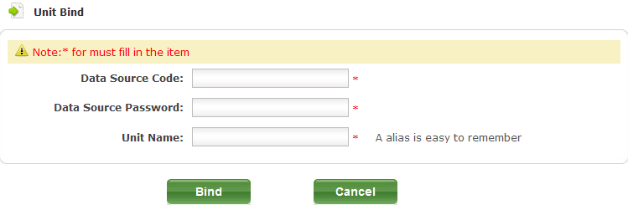
“Data sources code”, which is Serial No. of SolarInfo Logger, and “data source password” can be found on SolarInfo Logger nameplate. The unit name is the “data source code” by default and can be modified.
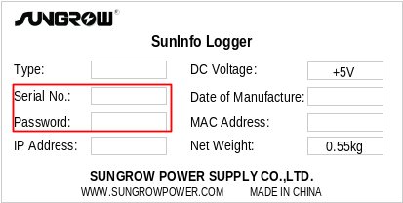
☑ The unit is bound successfully.
Each collector can only be bound to one unit. After a unit is bound successfully, the number of units will be displayed behind the unit list in the navigation bar.
- Unit List Page
1. Select “Plant List -> Plant Name” from the navigation bar.
2. Select “Plant Data -> Unit List” from the navigation bar to enter the “Unit List” page.
The unit list includes summary list and detail list. The summary list displays main information about a unit. The detail list displays the detailed information about the unit.
Status: ““ indicates the unit is in the working state. “” indicates the unit is in the idle state, if a unit does not send data for more than 1 hour.
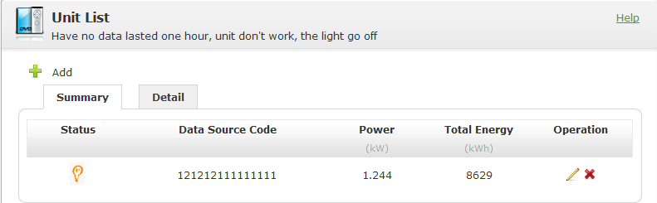
3. Click [Add]. The “Unit Bind” page is displayed. Fill in all required fields and then click [Bind].
☑ The unit is bound successfully.

6.5.2 Edit Unit
1. Select “Plant List -> Plant Name” from the navigation bar.
2. Select “Plant Data -> Unit List” from the navigation bar to enter the “Unit List” page.
3. Click [Edit].
4. The “Edit Unit” page is displayed. Edit the unit information and then click [Bind].
☑ The unit information editing is completed successfully.

6.5.3 Delete Unit
1. Select “Plant List -> Plant Name” from the navigation bar.
2. Select “Plant Data -> Unit List” from the navigation bar to enter the “Unit List” page.
3. Click [Delete].
4. The confirmation page is displayed. Click [Confirm] to delete the unit; Otherwise click [Cancel] to cancel the operation.
☑ The unit is deleted successfully.

6.6 Plant Overview
The plant overview briefly describes all plants and individual plants.
- All Plants
  - Data statistics information block
Today energy: The sum of energy yeild of all plants in the system of today;
Total energy: The sum of yield of all plants;
Avoided CO2: Multiply total energy by carbon dioxide conversion factor (the factor is set based on industrial rules and is set 0.6 currently);
Number of homes provided: Total energy is divided by 8 kilowatts-hour (8 kilowatt-hours is the daily consumption of a home).
  - Power quantity chart information block
Monthly yield chart displays the block diagram of daily yields of all plants in a month;
Yearly yield chart displays the block diagram of monthly yields of all plants in a year;
Total yield chart displays the block diagram of yearly yield of all plants.
  - Plant list and relevant information block
List all plants under the user, states, today energy, current power and Install power for each plant.
State: indicates the plant is in the working state. If a unit of a plant is in the working state, the plant is in the working state. indicates that the plant is in the idle state. If all units of a plant are in the idle state, the plant is in the idle state.
  - Plant map information block
All plants are displayed in Goggle Map.
- Individual Plants
  - Data statistics information block
Today energy: The sum of daily yield of all unit of a plant;
Total energy: The total yield of all unit of a plant;
Temperature: The average temperature from the environment detector is obtained first. If a plant has no environment detector equipped, the temperature is obtained from Yahoo Weather according to the country and city where the city is located. If the country and city of the plant is empty, only temperature unit is displayed.
Solar intensity: The solar intensity is obtained from the environment detector of the plant;
Avoided CO2: Multiply total energy by carbon dioxide conversion factor (the factor is set based on industrial rules and is set 0.6 currently);
Revenue: Multiply total yield by revenue conversion rate (the revenue conversion rate is set in the user information).
  - Power quantity chart information block
Daily power chart displays power and solar intensity chart of a plant every five minutes in a day;
Monthly yield chart displays the block diagram of daily yield of the plant in a month;
Yearly yield chart displays the block diagram of monthly yields of the plant in a year;
Total yield chart displays the block diagram of the yearly yield of the plant.
  - Information block of the unit list and relevant information
Displays the unit list, working states of units, today’s yield and power of a plant.
State:
indicates the unit is in the working state. The unit stops sending data for less than one hour.
indicates the unit is in the idle state. The unit stops sending data for more than one hour.

6.6.1 Overview of All Plants
1. Select “Plant List -> All Plants” from the navigation bar.
2. Select “Plant Data -> Plant Overview” from the navigation bar. The "Overview” page is displayed.
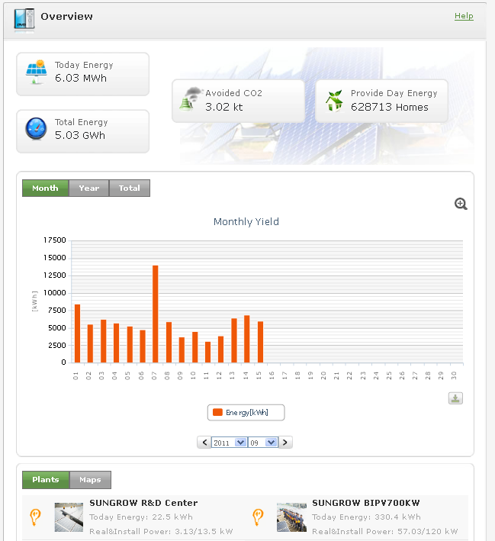

6.6.2 Overview of Individual Plants
1. Select “Plant List -> Plant Name” from the navigation bar.
2. Select “Plant Data -> Plant Overview” from the navigation bar. The “Overview” page is displayed.
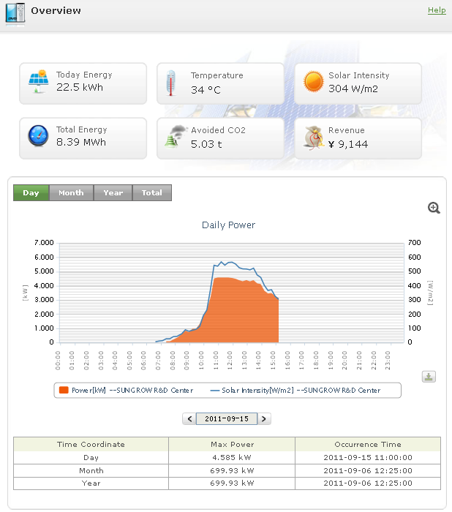

6.7 Plant Map
The plant map is to display the locations of plants in Google Map.

6.6.1 Map of All Plants
1. Select “Plant List -> All Plants” from the navigation bar.
2. Select “Plant Data -> Plant Maps” from the navigation bar. The "Plant Map” page is displayed.
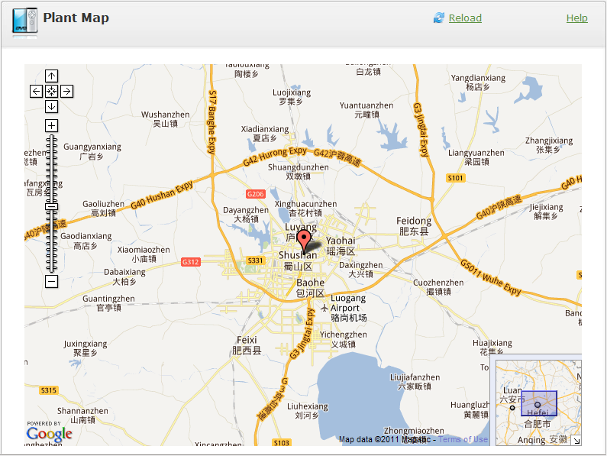
1. Click a plant icon on the map. The plant information box is displayed. Then you can view basic information of the plant.
2. Click “Enter” on the box to enter the overview page of the plant.
3. If the map is loaded incompletely due to network issues, click “Refresh” to load it again.

6.7.2 Map of Individual Plants
1. Select “Plant List -> Plant Name (of a plant)” from the navigation bar.
2. Select “Plant Data -> Plant Maps” from the navigation bar. The "Plant Map” page is displayed.
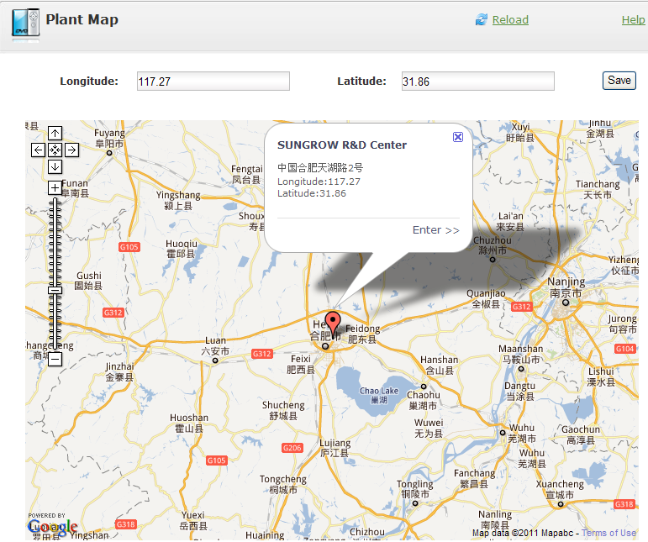
1. Click a plant icon on the map. The plant information box is displayed. Then you can view basic information of the plant.
2. Click “Enter” on the box to enter the overview page of the plant.
3. You can modify the longitude and latitude values of the plant.
4. If the map is loaded incompletely due to network issues, click “Refresh” to load it again.

6.8 Plant Log
Plant logs are log information generated at equipment failure during plant operation. You can inquire such information. Logs need to be confirmed manually.
1. Select “Plant List -> All Plants/Plant” from the navigation bar.
2. Select “Plant Data -> Logs” from the navigation bar to open the "Logs” page.
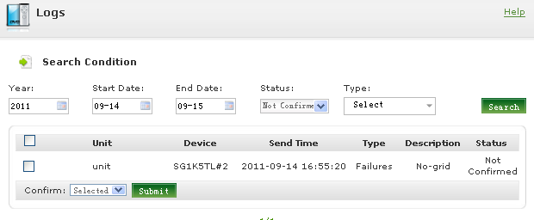
1. If unconfirmed logs exist, the number of unconfirmed logs will be displayed after “Logs” in the navigation bar.
2. You can inquire logs by time, state, plant and error type.
3. Logs need to be confirmed manually. You can select logs to confirm or confirm all unconfirmed logs.
4. Logs can be classified into three types: failure, error and alarm.
5. If alarm information is logged, the system will automatically send the alarm information to the e-mail address set in the event report.

6.9 Plant Analysis Chart
Analysis charts are generated according to data of plants. In the chart, click the [Zoom] icon to view the magnified chart.
All charts are downloadable. You can click the [Download] icon below the chart to download data in the chart to local computer in csv format.
The time of all charts should be later than the time when the plant is added to SolarInfo Bank.

6.9.1 Chart of All Plants
- Monthly Yield Chart
Open the overview page of all plants to view the chart information block. The “Monthly Yield" chart is displayed by default, in which the block diagram of daily yield of all plants in a month displayed, as shown below:
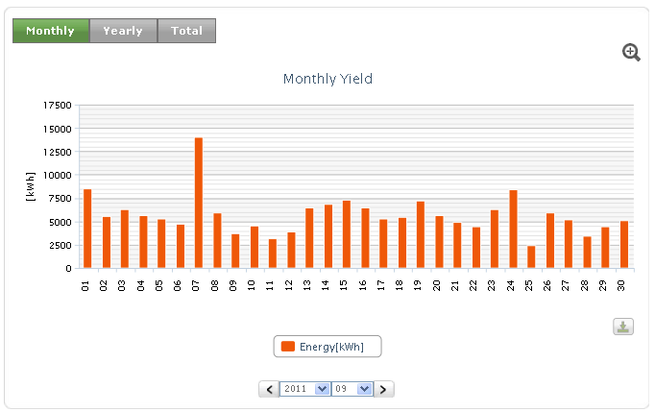
- Yearly Yield Chart
On the overview page of all plants, click the [Yearly] tab to open the “Yearly Yield” Chart to display the block diagram of monthly yields of all plants in a year, as shown below:
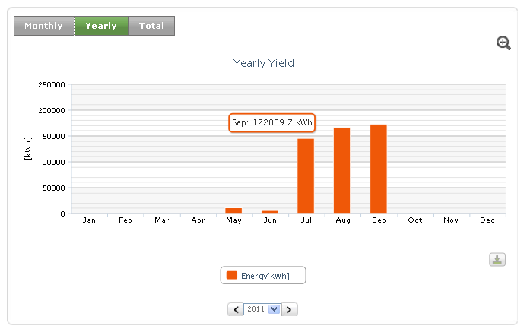
- Total Yield Chart
On the overview page of all plants, click the [Total] tab to open the “Total Yield” Chart to display the block diagram of total yields of all plants in all years, as shown below:
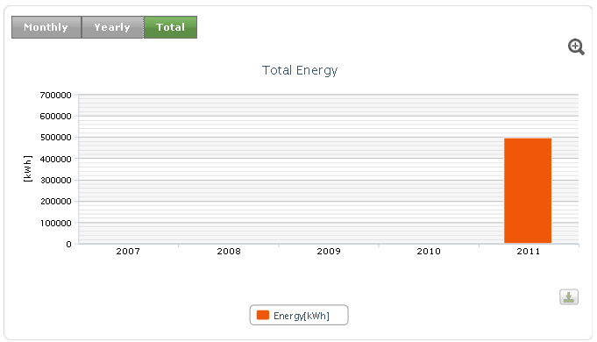
- Yearly Yield Comparison
1. Select “Plant List -> All Plants” from the navigation bar.
2. Select “Analysis Chart -> Yearly Yield Comparison” from the navigation bar. The “Yearly Yield Comparison” chart is displayed to display the block diagram of comparison of monthly yields in each year of all plants, as shown below:
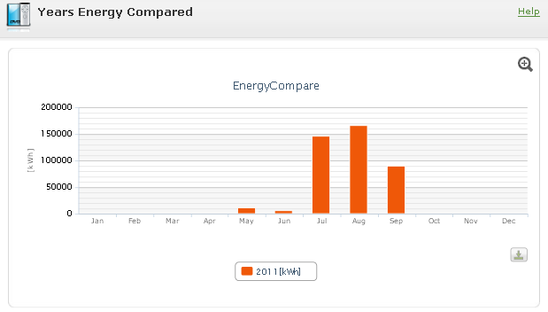
- Rate of Invest-Income
The rate of invest-income comparison chart includes daily revenue comparison, monthly revenue comparison, yearly revenue comparison and total revenue comparison charts.
  - Daily revenue comparison
1. Select “Plant List -> All Plants” from the navigation bar.
2. Select “Analysis Chart ->Rate of Invest-Income" from the navigation bar. The “Rate of Invest-Income” chart is displayed, as shown below: The “Rates of Invest-Income Compare in Planrs” chart is displayed by default, in which the comparison of invest-income rates at each integral point in a day of all plants is displayed, as shown below:
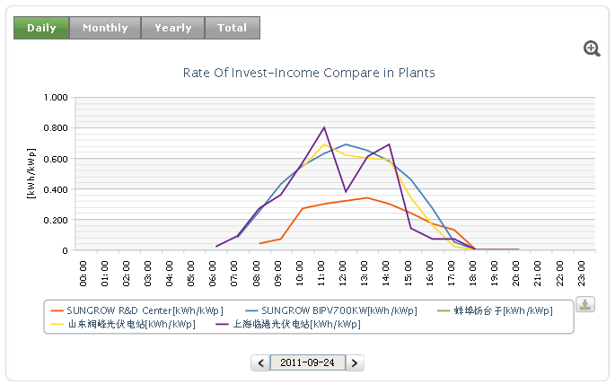
  - Monthly revenue comparison
On Rate of Invest-Income page, click the [Monthly] tab to open the “Monthly Revenue” comparison chart, in which the daily investment-income rates comparison curve of all plants in a month is displayed, as shown below:
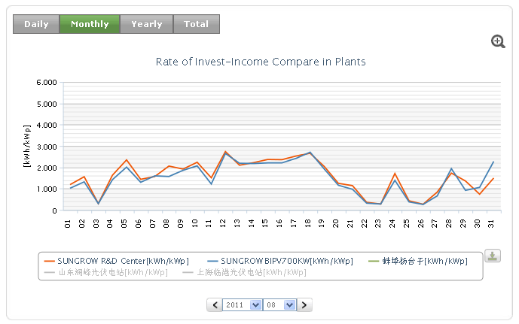
  - Yearly revenue comparison
On Rate of Invest-Income page, click the [Yearly] tab to open the “Yearly Revenue” comparison chart, in which the monthly invest-income rate comparison curve of all plants in a year is displayed, as shown below:
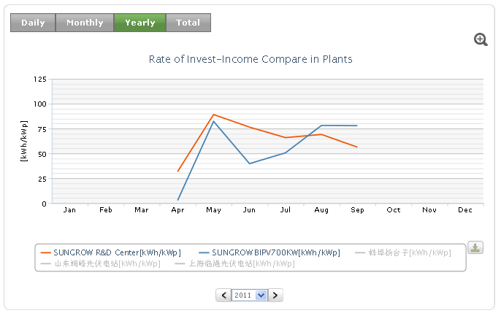
  - Total revenue comparison
On Rate of Invest-Income page, click the [Total] tab to open the “Total Revenue” comparison chart, in which the investment-income rate comparison of all plants in all years is displayed, as shown below:
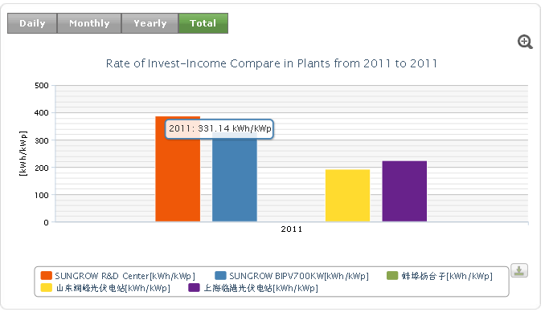

6.9.2 Individual Plant Chart
- Daily Power Chart
Open the individual plant overview page to view the chart information block. The “Daily Power” chart is displayed by default as shown below. The surface chart of power of a plant every five minutes in a day is displayed. In the table, the daily, monthly and yearly maximum power and times are listed.
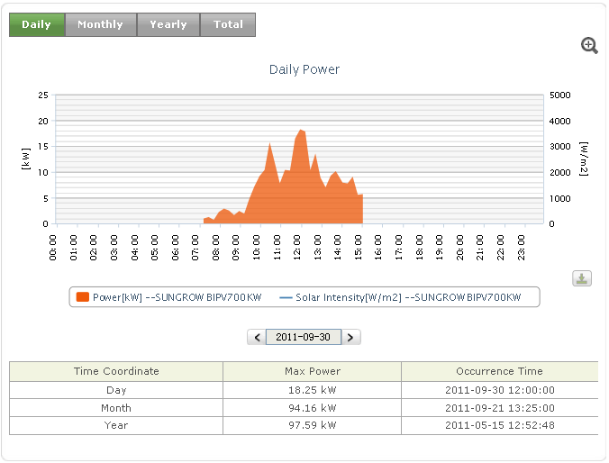
- Monthly Yield Chart
On the plant overview page, click the [Month] tab to open the “Monthly Yield” chart to display the block diagram of daily yields of the plant in a month, as shown below:
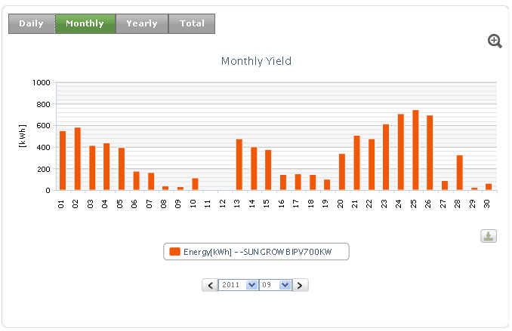
- Yearly Yield Chart
On the plant overview page, click the [Year] tab to open the “Yearly Yield” chart to display the block diagram of monthly yields of the plant in a year, as shown below:
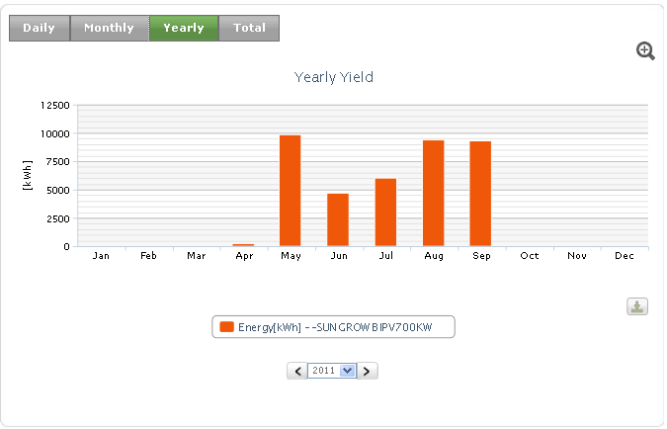
- Total Yield Chart
On the overview page of all plants, click the [Total] tab to open the “Total Energy” Chart to display the block diagram of total yields of all plants in all years, as shown below:
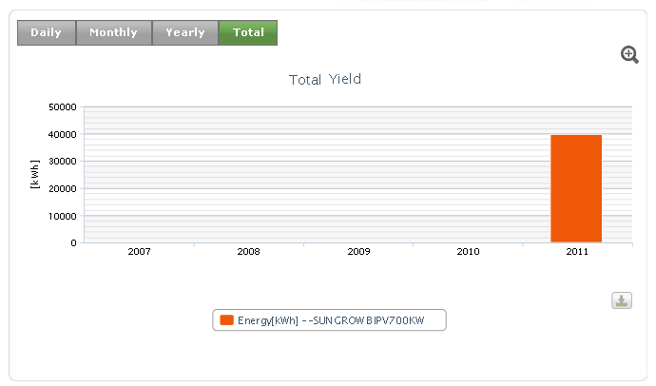
- Daily Comparison Chart
The daily comparison chart includes power and solar intensity comparison chart, and yield and solar intensity comparison chart.
  - Power and solar intensity comparison
1. Select “Plant List -> Plant Name (of a plant)” from the navigation bar.
2. Select “Analysis Chart -> Daily Comparison Chart” from the navigation bar. The “Power and solar intensity Compare” chart is displayed by default, in which the daily power and solar intensity comparison curve of a plant every five minutes in a day is displayed, as shown below:
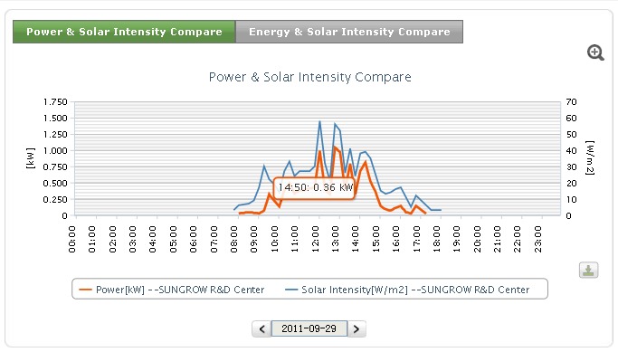
  - Yield and solar intensity comparison
In the daily comparison chart, click the [Energy &Solar Intensity Compare] tab to open the “Energy & solar intensity Compare” chart, in which the daily yield and solar intensity comparison chart of a plant at each integral point in a day is displayed, as shown below:
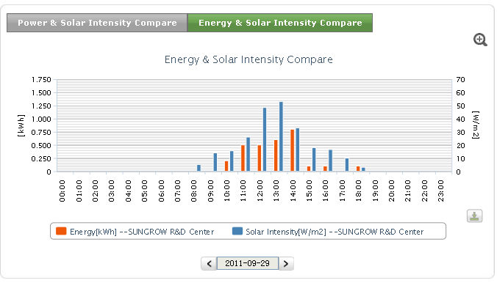
- Total Yield and Investment Comparison
The total yield and investment comparison chart includes total yield comparison chart and yearly investment-income rate comparison chart.
  - Total yield comparison chart
1. Select “Plant List -> Plant Name (of a plant)” from the navigation bar.
2. Select “Analysis Chart -> Total Yield and Investment Comparison” from the navigation bar. The “Total Yield Comparison” chart is displayed by default to display the block diagram of comparison of monthly yields in each year of a plant, as shown below:
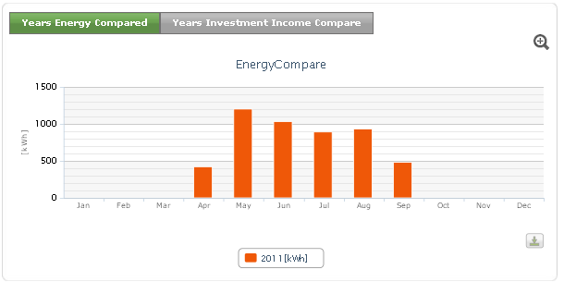
  - Yearly investment-income rate comparison chart
On the “Total Yield and Investment Comparison” page, click the [Yearly Investment-Income Rate Comparison] tab to open the “Yearly Investment-Income Rate Comparison” chart, in which the block diagram of investment-income rate comparison of 12 months in a year of a plant is displayed.
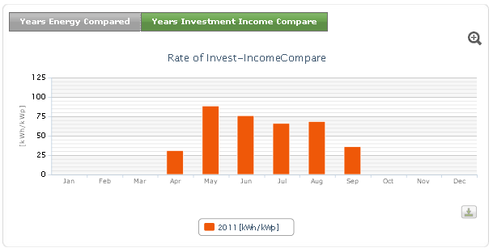
- Investment-Income Rate
The investment-income comparison chart includes daily revenue rate and solar intensity comparison, monthly revenue comparison, yearly revenue comparison and total revenue comparison charts.
  - Daily revenue rate and solar intensity
1. Select “Plant List -> Plant Name (of a plant)” from the navigation bar.
2. Select “Analysis -> Investment-Income Rate” from the navigation bar to open the “Investment-Income Rate” page. By default, the “Daily Revenue Rate and Solar Intensity” comparison chart is displayed, in which the revenue and solar intensity comparison at integral points in a day of a plant is displayed, as shown below:
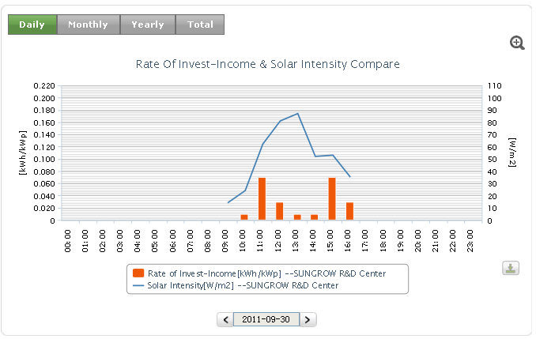
  - Monthly revenue rate
On the investment-income rate page, click the [Monthly] tab to open the “Monthly Revenue Rate” comparison chart, in which the block diagram of daily investment-income rates comparison of a plant in a month is displayed, as shown below:
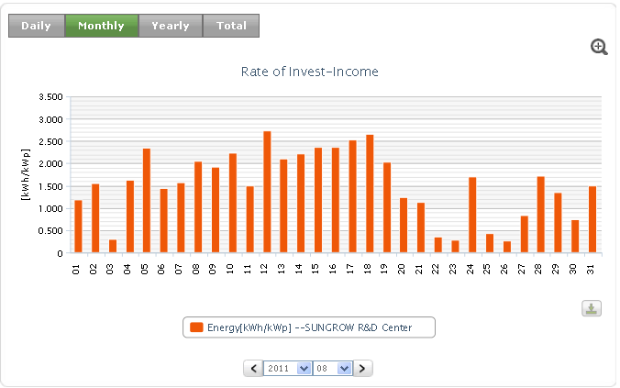
  - Yearly revenue rate
On the investment-income rate page, click the [Yearly] tab to open the “Yearly Revenue Rate” comparison chart, in which the block diagram of monthly investment-income rates comparison of a plant in a year is displayed, as shown below:
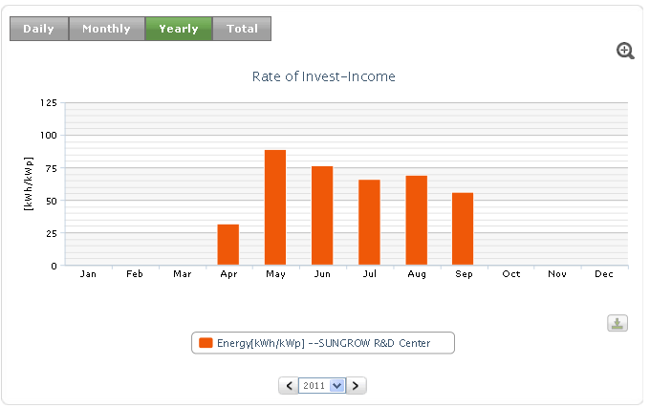
  - Total revenue comparison
On the investment-income rate page, click the [Total] tab to open the “Total Revenue Rate” comparison chart, in which the block diagram of the investment-income rate comparison of a plant in all years is displayed, as shown below:
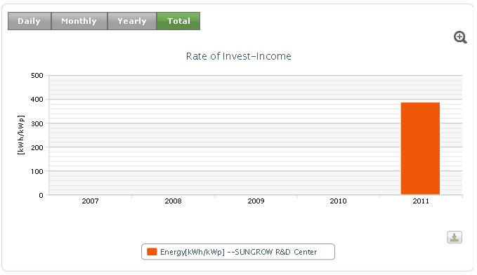

7 Equipment Management
The unit list menu is displayed on the navigation bar only under the individual plant page. The list lists all units and equipments under units of a plant. You can use the unit list to view charts of all units and charts of equipments, real-time data and alarm information. In the unit menu of plants, the number of equipments of a unit is displayed. If an equipment works abnormally under a unit, the icon is displayed after the unit.

7.1 Unit Chart
The unit list displays the daily comparison charts, monthly comparison charts and yearly comparison charts of all equipments under a unit.
In the chart, click the [Zoom] icon to view the magnified chart.
All charts are downloadable. You can click the [Download] icon below the chart to download data in the chart to local computer in csv format.
- Daily Comparison Chart
1. Select “Plant List -> Plant Name (of a plant)” from the navigation bar.
2. Select “Device Data->Unit” to open the “Unit Chart” page. The “Daily Comparison Chart” is displayed by default, as shown below.
kWh/kWp: The inverter efficiency. If the yield of unit power is higher, it indicates that the invest-income rate is higher.
This chart displays the comparison of invest-income rates of multiple equipments at all integral points in a day.
If an equipment has no value, it will be displayed “None” in red.
When the invest-income value is 20% higher than the average value, it is displayed in blue.
When the invest-income value is 20% lower than the average value, it is displayed in orange.
The average value in the invest-income chart is the average value of all working devices at the same integral point.
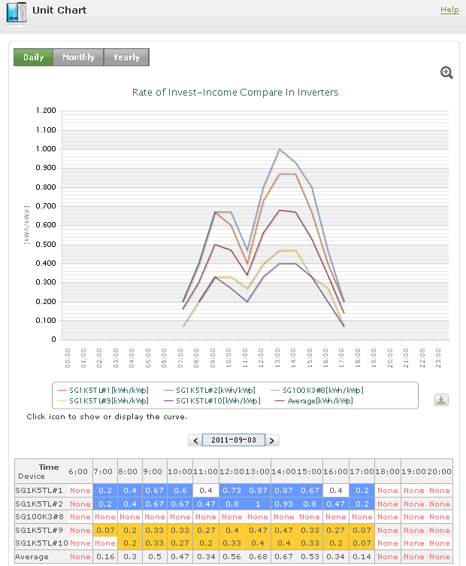
- Monthly Comparison Chart
In the unit chart, click the [Monthly] tab. The “Monthly Comparison Chart” is displayed, as shown below, This chart displays the comparison of invest-income rates of multiple devices every day in a month.
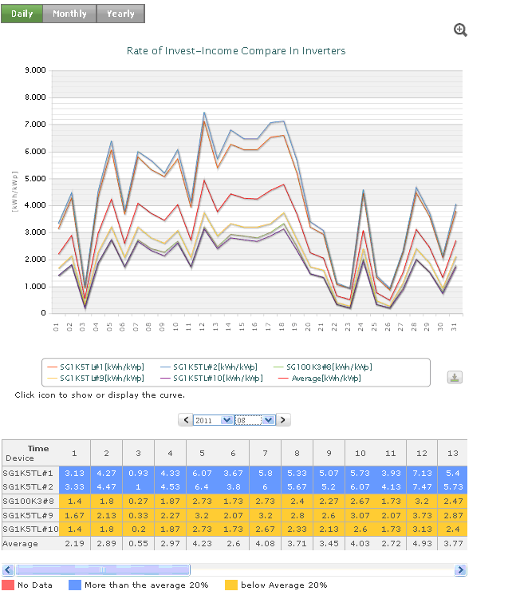
- Yearly Comparison Chart
In the unit chart, click the [Yearly] tab. The "Yearly Comparison Chart” is displayed, as shown below, This chart displays the comparison of investment-income rates of multiple devices every month in a year:
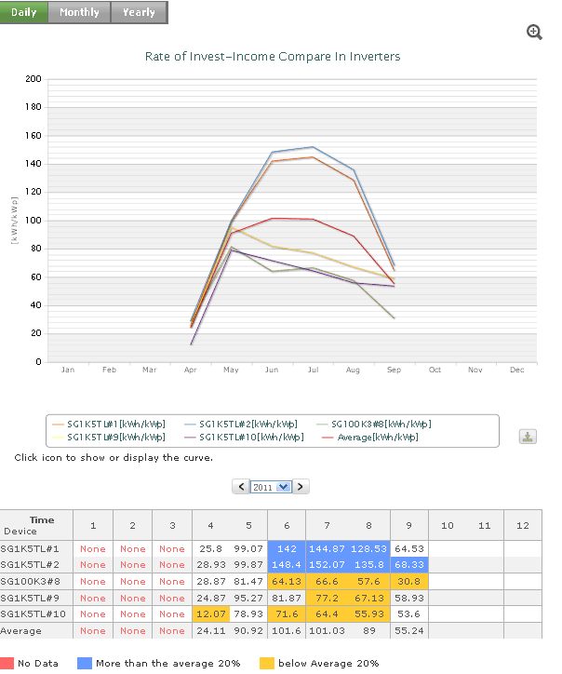

7.2 Equipment Data
The equipment data is divided into inverter data and environment monitoring device data.
The inverter equipment page displays equipment charts (daily power and solar intensity comparison chart, daily/kWp comparison chart, monthly yield chart, yearly yield chart, total yield chart), real-time operation data and alarm information.
The environment monitoring device page displays the daily chart, real-time operation data and alarm information.

7.2.1 Chart
- Inverter Chart
  - Daily power and solar intensity comparison
1. Select “Plant List -> Plant Name (of a plant)” from the navigation bar.
2. Select “Device Data -> Unit -> Inverter Name” from the navigation bar to open the “Device Data” page. The daily “Power and Solar Intensity Compare” chart is displayed by default, as shown below. This chart displays the power and solar intensity comparison curve at all integral points of an inverter. In the table, the daily, monthly and yearly maximum power and occurrence times of the equipment are listed.
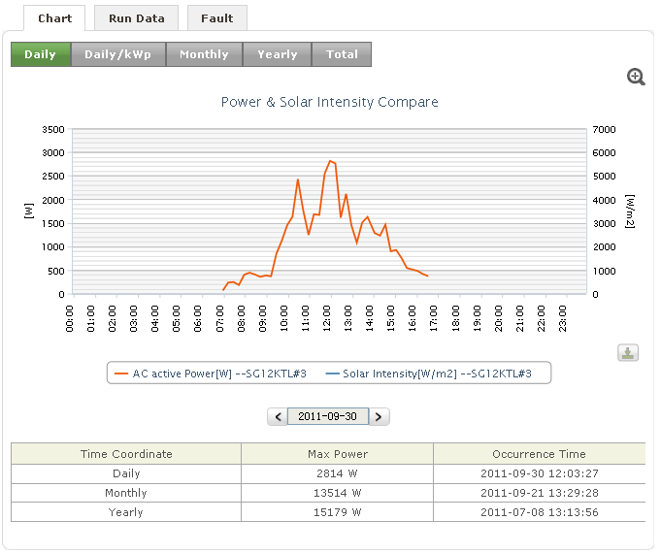
  - Day/kWp Comparison Chart
In the equipment chart, click the [Day/kWp] tab. The "Rate of Invest-Income compare chart” is displayed, as shown below. This chart displays the block diagram of comparison between the yield and solar intensity under unit power at each integral point of the equipment.
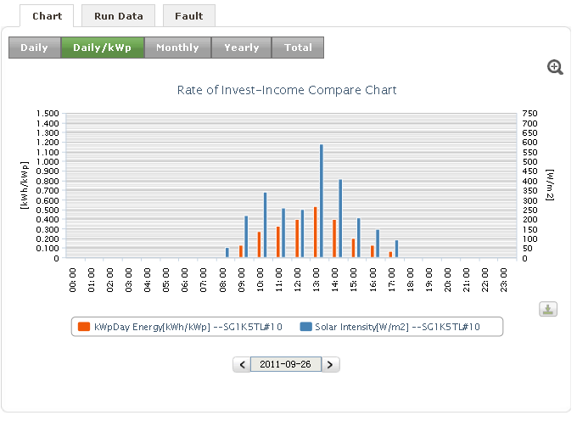
  - Monthly Yield Chart
In the equipment chart, click the [Month] tab. The inverter "Monthly Yield” chart is displayed, as shown below: This chart displays the block diagram of the inverter yield of all days in a month.
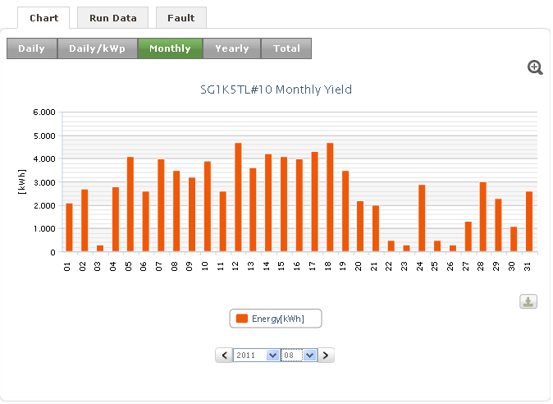
  - Yearly Yield Chart
In the equipment chart, click the [Year] tab. The inverter "Yearly Yield” chart is displayed, as shown below. This chart displays the block diagram of the inverter yield of all months in a year.
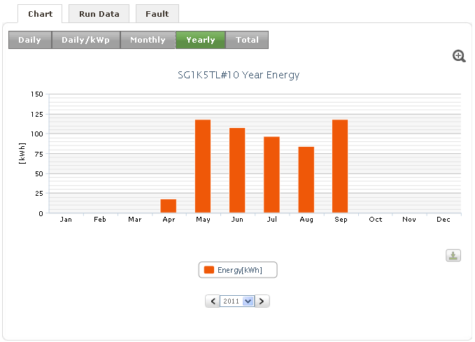
  - Total Yield Chart
In the equipment chart, click the [Total] tab. The inverter "Total Energy” chart is displayed, as shown below. This chart displays the block diagram of yields of multiple years of the inverter.
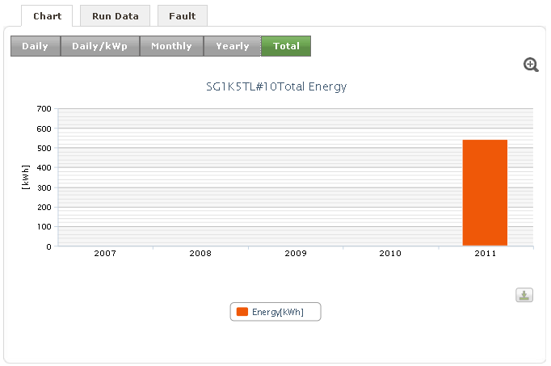
- Environment Monitoring Device Chart
1. Select “Plant List -> Plant Name (of a plant)” from the navigation bar.
2. Select “Device -> Unit -> Environment Monitoring Device” from the navigation bar. The “Equipment Chart” is displayed, showing the “Daily Chart” of the environment monitoring device as shown below: This chart displays the solar intensity curve every five minutes in a day. The table displays the maximum solar intensity in a day, in a month and in a year. And respectively occurrence time is also included.
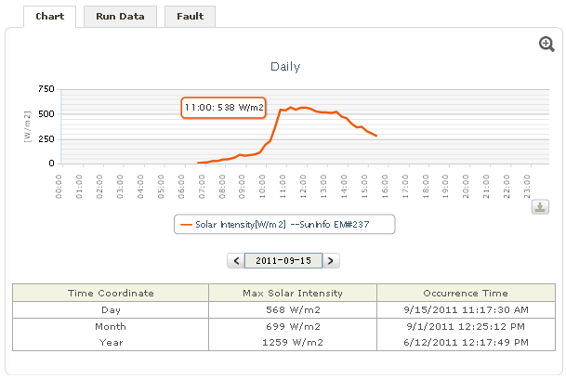

7.2.2 Real-time Data
On the “device data” page, select the [Run Data] tab. The page shows real-time data of the device, as shown below. The latest updated time displays the last update time.
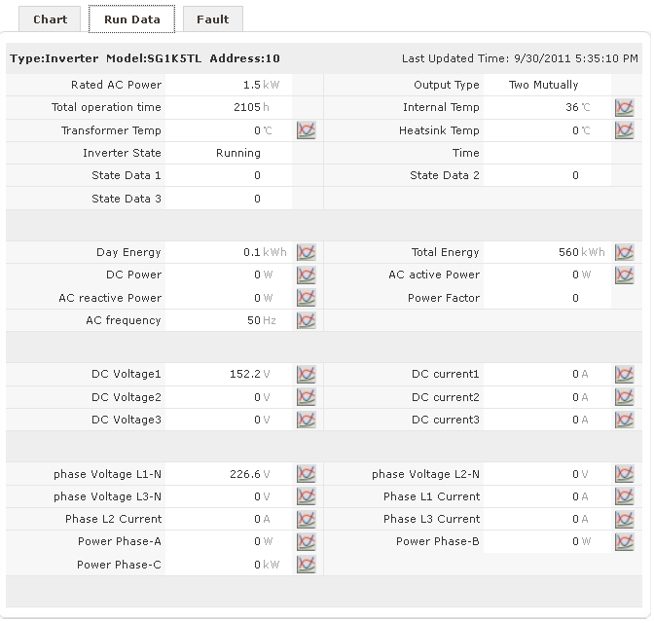

7.2.3 Fault Information
On the device data page, select the [Fault] tab. The unconfirmed fault information is displayed, as shown below. Fault information needs to be confirmed manually. You can confirm information by selecting relevant information and confirm all unconfirmed information.
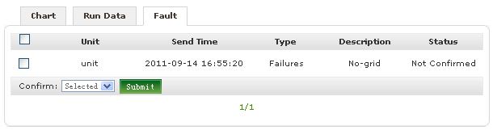

7.3 Device Monitoring Function
Under a single plant, you can view the real-time operation situations of equipment (inverter, environment monitoring device, combiner box) of the plant through device monitoring function. If any equipment is abnormal, the icon is displayed after the equipment in the “Device Monitoring” menu in the navigation bar.
1. Select “Plant List -> Plant Name (of a plant)” from the navigation bar.
2. Select “Plant Data -> Device Monitoring” from the navigation bar. The equipment monitoring page is displayed, as shown below:
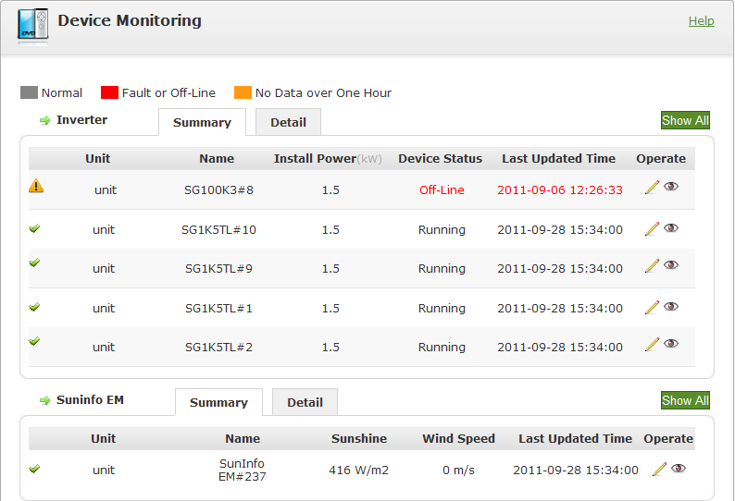
- Summary contents of inverter, environment monitoring device (SolarInfo EM) and combiner box
  - The equipment list includes the summary list and detail list. The summary list describes the main information of the equipments and the detail list describes the detailed information of the equipments.
  - For normal equipment, the device status and the last updated time are displayed in gray. For equipment having no data for over one hour and below two days, the device status and the last updated time are displayed in orange. For equipment having no data for over two days, the device status and the last updated time are displayed in red, indicating that faults may occur to the equipment.
  - Equipments with faults are listed in front and identified with the icon. Non-faulty equipments are listed after and identified with the icon.
  - Hide or show equipment
Click the (hide) icon in the list. The equipment is hidden and will not be displayed in relevant pages.
Click [Show All]. All equipments (both hidden and unhidden) are shown.
Click the icon behind hidden equipment. The equipment is displayed. At the same time, the equipment is displayed normally in the equipment list.
- Inverter List
You can modify the installation power and device name in the list.
1. Click [Edit].
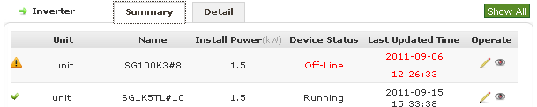
2. The “Edit Device” page is displayed.
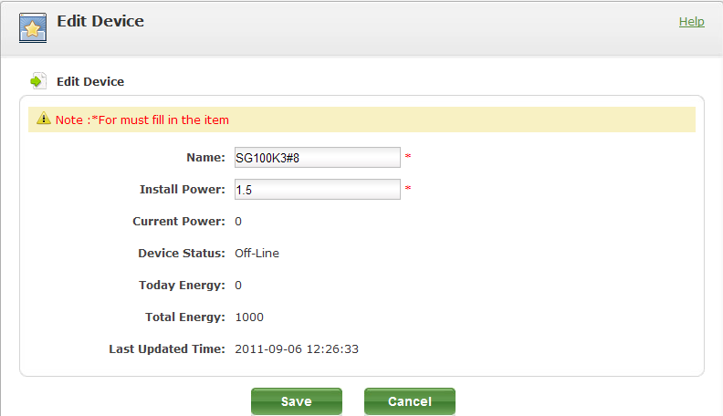
3. Modify the installation power or name and then click [Save].
☑ The equipment information is modified successfully. The system returns to the “Device Monitoring” page.
- Environment Detector List
You can modify the equipment name.
1. Click [Edit].
2. The “Edit Device” page is displayed.
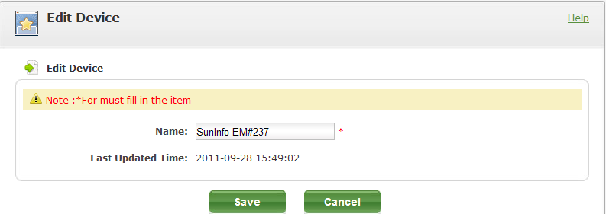
3. Modify the name and then click [Save].
☑ The equipment information is modified successfully. The system returns to the “Device Monitoring” page.
- Combiner Box List
You can modify the equipment name and the actual connections.
1. Click [Edit].
2. The “Edit Device” page is displayed.
3. Modify the equipment name and then click [Save].
☑ The equipment information is modified successfully. The system returns to the “Device Monitoring” page.

8 Video Monitoring
After making settings through video monitoring, you can observe the real-time operation situations of the equipment. You can set multiple video monitoring points to view situations at all monitoring points.

8.1 Add Video Monitoring
The video monitoring menu is displayed on the navigation bar only when the video monitoring value is set to “Enable” during plant adding or editing. Then you can use the video monitoring function. If it is set to “Disable”, the video monitoring menu will not be displayed on the navigation bar.
1. On the add or edit plant page, set the value of the video monitoring to “Enable”.
2. Select “Plant List -> Plant Name (of a plant)” from the navigation bar.
3. Select “Video Monitor -> Add it into Monitoring”. The video monitoring page is displayed, a shown below:
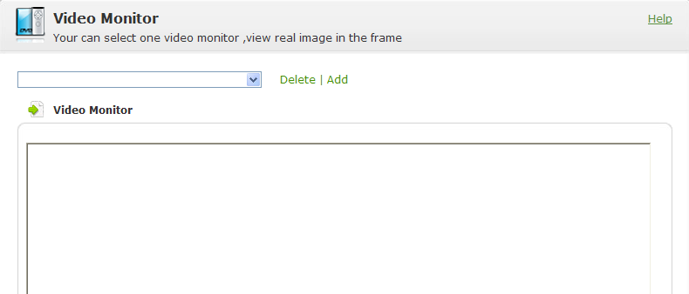
4. Select [Add], as shown below:
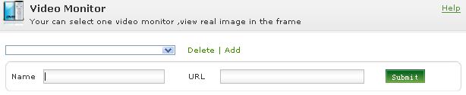
5. Enter the video name and monitoring address correctly and then click [Submit].
6. The “Success” box is displayed. Click [Confirm].
☑ The video monitoring point is added successfully.
All added video monitoring names will be listed in the video monitoring menu on the navigation bar.

8.2 View Video Monitoring
1. Select “Plant List -> Plant Name (of a plant)” from the navigation bar.
2. Select “Video Monitor -> Video Monitoring Name”. The video monitoring page is displayed, a shown below:
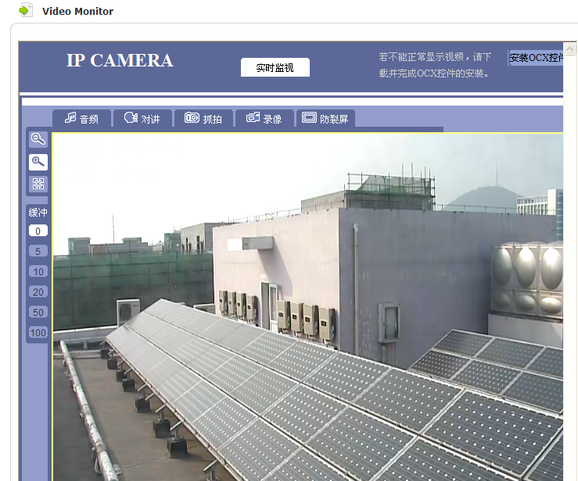
You can view video monitoring through the monitoring dropdown list to grasp the operation situations at all monitoring points.

8.3 Delete Real-time Monitoring
1. On the video monitoring page, select a video monitoring point.
2. Click [Delete]. The confirmation box is displayed.
3. Click [Confirm].
☑ The video monitoring is deleted successfully.

9 Configuration

9.1 Customized Charts
You can create charts and make relevant configurations to generate charts.

9.1.1 Create Charts
1. Select “Plant List -> Plant Name (of a plant)” from the navigation bar.
2. Select "Configure -> Create Chart” from the navigation bar. The “User-defined” page is displayed, as shown below:
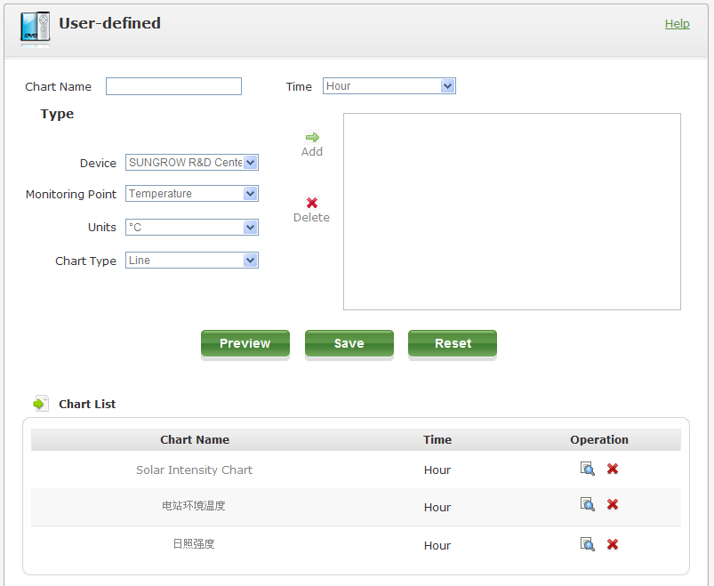
If different time units are selected, the monitoring points of the equipment will also be different. And if different time units are selected, supported chart types will also be different. The chart type varies dependant on time units. Different points will have different time units. The time unit varies with the monitoring points.
Time Unit | Supported Chart Type
Hour | Linear Chart, Curve Chart
Day | Linear Chart, Block Diagram
Month | Linear Chart, Block Diagram
Year | Linear Chart, Block Diagram
3. Enter the chart name and select time type. Then select equipment, monitoring point, unit and chart type.
4. Click [Add].
5. Repeat Step 3 and 4. Multiple items can be added.
6. Click [Save].
7. The “Success” box is displayed. Click [Confirm].
☑ The chart adding is completed successfully.
After the chart is added, the chart is displayed in the “Analysis Chart -> Customized Chart” menu on the navigation bar.

9.1.2 Preview Chart
1. Enter the chart name and select time type, equipment, monitoring point, unit, value and chart type.
2. Click [Add].
3. Repeat Step 1 and 2. Multiple items can be added.
4. Click [Preview]. The chart preview page is displayed. You can preview the chart information.

9.1.3 Delete Chart
1. In the chart list, click “Delete”.
2. The confirmation box is displayed. Click [Confirm].
☑ The chart is deleted successfully.

9.1.4 View Chart
- In the chart list, click the name of a chart to view the chart.
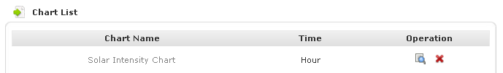
- On the navigation bar, click the name of chart.
1. After a chart is created, the chart name is displayed in the customized chart list on the navigation bar. At the same time, the number of customized charts is displayed.
2. Select “Plant List -> Plant Name (of a plant)” from the navigation bar.
3. Select “Analysis Chart -> Customer Chart -> Chart Type” to view customized charts.

9.2 Reports
You can send reports containing plant data information on the SolarInfo Bank page to you. These reports are sent through e-mails and can be divided into two types: operation report and event report.

9.2.1 Operation Report
The operation report can be classified into five types: daily report, report of recent 7 days, monthly report, yearly report and total report. In addition, the operation report can also be divided into pre-defined report and customized report. Pre-defined reports are pre-set by the system and can be modified by users. In addition, you can also create any of the five type reports.
- Create Operation Report
Daily reports are sent every day. Reports of recent seven days are sent every week. Monthly reports are sent every month and yearly reports are sent every year. Total reports are also sent every year. You can set any of these reports.
Sending time of reports:
Report Name | Sending Time
Daily report | Periodic sending and fixed time sending.  Sending time interval can be set for periodic sending. By default, it is 4 hours and adjustable.  For fixed time sending, reports are sent at 20:00 each day by default and the time is adjustable.
Report of recent 7 days | Fixed time sending. By default, these reports are sent at 4 on each Monday and the time can be modified.
Monthly report | Fixed time sending. By default, these reports are sent at 4 on the first day of each month and the time can be modified.
Yearly report | Fixed time sending. By default, these reports are sent at 4 on the first day of January each year and the time can be modified.
Total report | Fixed time sending. By default, these reports are sent at 4 on the first day of January each year and the time can be modified.
Operation reports can be created under all plants and individual plants. Operation reports under all plants list data of all plants. Operation reports of an individual plant list the operation reports of the plant.
1. Select “Plant List -> All Plants/Plant” from the navigation bar.
2. Select "Configure -> Reports” from the navigation bar. The “Operation Report List” page is displayed, as shown below:
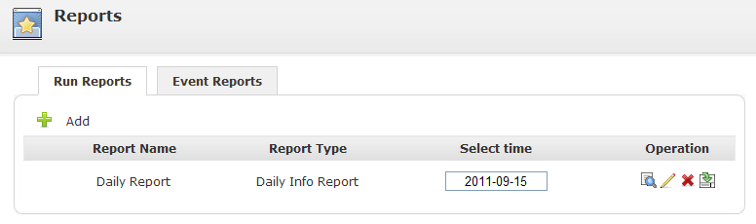
3. Click [Add]. The "Create Report” page is displayed, as shown below:
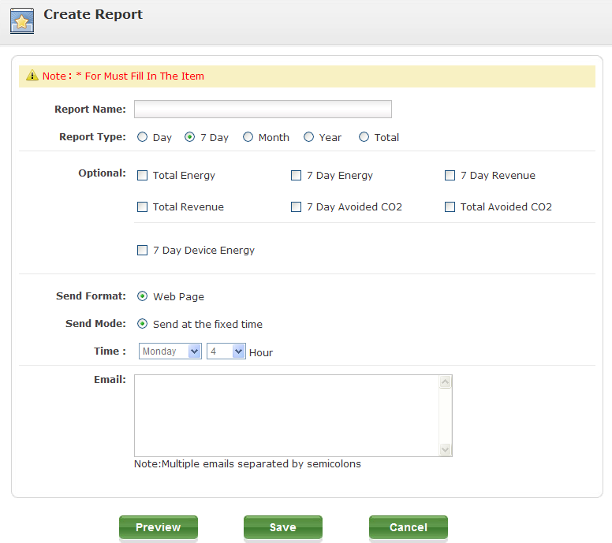
4. Set the report.
Report Name | Enter the report name
Report type | Select one of the five report types: daily, recent seven days, monthly, yearly and total reports
Optional data items | Select data items that will be displayed in the report
Sending format | Reports are sent in the form of web pages.
Sending mode | Select the sending mode of reports. Daily reports can be sent in the periodic mode and fixed time mode and other reports are sent in the fixed time mode.
Sending Time | Set the sending time of reports.
E-mail | Set the E-mail address for receiving reports.
5. Click [Save].
☑ Report is set successfully. The system returns to the report list page.
- Preview Operation Report
1. On the Create Report page, enter the report name and select data items.
2. Click [Preview] to open the “View Report” page.
- View Operation Report
1. In the operation report list, click [View].
2. The Report page is displayed. You can view information in the report.
- Edit Operation Report
1. In the operation report list, click [Edit].
2. The “Edit Report” page is displayed.
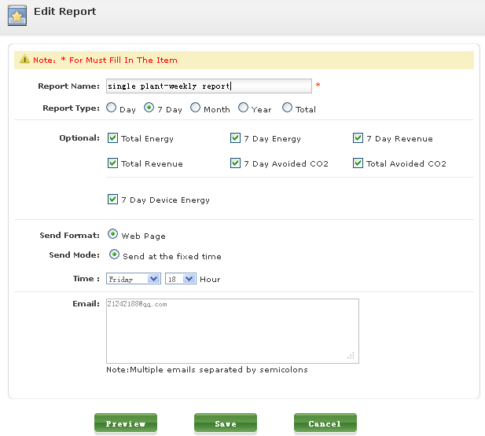
3. After the information modification is complete, click [Save].
☑ Report is modified successfully. The system returns to the report list page.
- Download Operation Report
1. In the operation report list, click [Download].
2. The download prompt box is displayed. Click [Save] to download the report to local computer. The file is in the csv format.
- Delete Operation Report
1. In the operation report list, click [Delete].
2. The confirmation box is displayed. Click [Confirm].
☑ The report is deleted successfully.

9.2.2 Event Report
When exceptions occur in equipment, the system will send relevant information to the set e-mail address immediately.
- Configure Report
Event reports can only be configured under the individual plant mode.
1. Select “Plant List -> Plant Name (of a plant)” from the navigation bar.
2. Select "Configure ->Reports” from the navigation bar. The “Operation Report List” page is displayed.
3. On the “Operation Report List” page, click [Event Report] tab. The event report configuration page is displayed, as shown below:
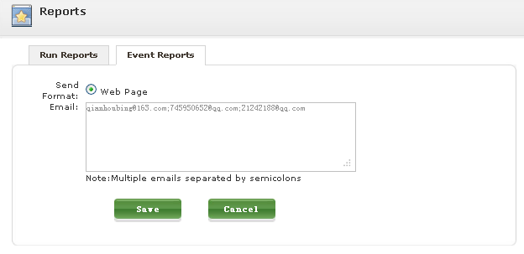
4. Click [Save]. The success box is displayed.
5. Click [Confirm].
☑ The report configuration is complete successfully.
The report configuration is saved successfully. When exceptions occur to equipment in the system, the system will send notification e-mails to users.

9.3 User Authority
The SolarInfo Bank has three user roles: system administrator, common user and plant maintainer.
System administrator: enjoy all authorities of the user.
Common user: Allow to view the plant list, plant profile, plant overview, plant map and video monitor of plants assigned by the administrator. The user cannot view and modify personal information.
Plant maintainer: operate plants assigned by the administrator and can view and modify personal information.

9.3.1 Create Plant User
Only the system administrator is allowed to create users (common user, plant maintainer and system administrator) and manage created users. The creator of a plant is the system administrator of the plant by default and cannot be deleted from the plant user list.
1. Select “Configure -> Plant Users” from the navigation bar. The “Plant User List” page is displayed, as shown below:
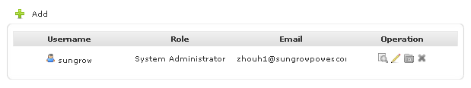
The creator of a plant is identified by and is the system administrator of the plant. Plant creators cannot be deleted from plant user lists and no plant needs to be assigned to them.
2. Click [Add]. The “Create User” page is displayed.
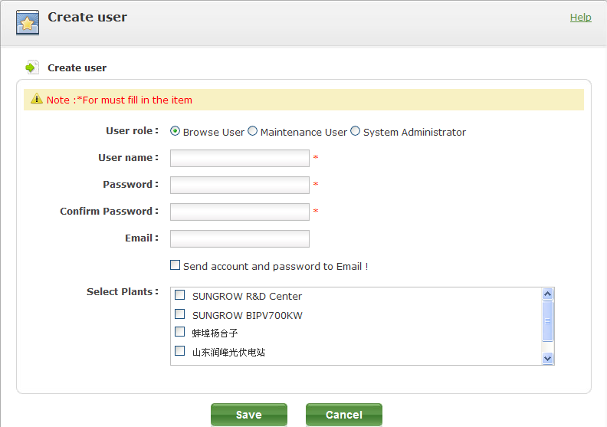
3. Fill in all required fields according to the requirements and click [Save].
☑ The user adding is completed successfully.

9.3.2 Edit Plant User
1. In the plant user list, click [Edit].
2. The “Edit User” page is displayed.
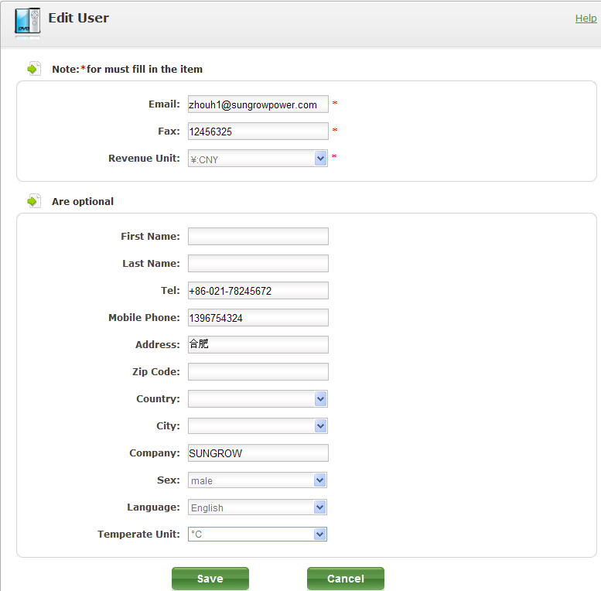
3. After the information modification is complete, click [Save].
☑ The user information modification is complete successfully.

9.3.3 View Plant User Information
1. On the plant list page, click [View]. The “Plant User Information” page is displayed.
2. This page displays plant user information.

9.3.4 Modify Plant Assignment
1. In the plant user list, click [Assign].
2. After the plant assignment modification is complete, click [Save].
☑ The plant assignment is completed successfully.

9.3.5 Delete Plant User
1. In the plant user list, click [Delete]. The confirmation box is displayed.
2. Click [Confirm].
☑ The plant user deletion is completed successfully.
Deleted users cannot log in to the system again.

10 Contact Information

Disclaimer
Please follow the general terms and conditions of Sungrow.
Necessary check and revisions will be made to this document. However, mistakes may still exist in the document and we are not to make any guarantee on the integrity of the document. The latest versions of the document can be obtained at www.suninfobank.com or through general sales channels.

About US
Sungrow power supply is a China-leading manufacturer of various power electronics products for renewable energy generation systems. Our products include converters, inverters, battery chargers and other power supplies for distributable generation system in both grid-connected and stand-alone applications. The power rating of Sungrow products covers from several hundred watt to large mega-watt systems.
The pursuit of Sungrow is to help our customers acquire stable and clean power with minimum cost, maximum reliability and enhanced safety.
Trademarks
is the registered trademark of Sungrow Power Supply Co., Ltd..
Contact Information
If you have any questions about this product, our hotline will be happy to assist you. Please keep the following data when contacting Sungrow.
Company: | Sungrow Power Supply Co., Ltd.
Website: | www.sungrowpower.com
Contact: | Mr. Henry (Director of International Trade)
Email: | info@sungrow.cn, service@sungrow.cn
Address: | No.2 Tianhu Rd., New & High Technology Industrial Development Zone, Hefei, P.R.China
Zip: | 230088
Telephone: | +86 551 532 7834, +86 551 532 7845
Fax: | +86 551 532 7856

